Order No: 74 of 2025
Dated: 02-09-2025

Subject: Investigation and Resolution of Non-Functioning CCTV Systems in the Institution.

In view of the issues regarding the non-functioning of Closed-Circuit Television (CCTV) systems within the institution, the Institutional Development Committee is hereby tasked with conducting a comprehensive check and assessment of the CCTV issues to ensure prompt inspection, diagnosis, and rectification. The committee shall:
- Inspect CCTV installations to identify malfunctioning units, including cameras, recording devices, and associated infrastructure.
- Investigate the root causes of the non-functionality, such as technical faults, power supply problems, or maintenance lapses.
- Recommend necessary repairs, upgrades, or replacements to restore full operational status.
- Submit a detailed report on findings and proposed actions to the undersigned within 5 days.

This order shall remain in force until the issues are resolved or further modifications are issued.
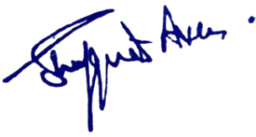

No:KGP/Estt/2025/969
Dated:02-09-2025
Dr. Shafquat Ara
Principal
Kashmir Govt.Polytechnic College Srinagar

Copy to the:
1. Members of the Institutional Development Committee for Compliance.

.

